Food_eda

March 13, 2024

[ ]:

**import pandas as pd**

**import matplotlib.pyplot as plt import seaborn as sns**

[ ]:

*# Load the data from the CSV file*

data = pd.read_csv('C:/Users/KIIT/Documents/Subjects/Food_Reccomender/

↪indian_food.csv')

[ ]:

*# Display basic information about the dataset*

print("Column Names:") print(data.columns) print("**\n**Data Types:") print(data.dtypes) print("**\n**Statistical Summary:") print(data.describe())

Column Names:

Index(['dishes', 'ingredients', 'diet', 'prep_time', 'cook_time', 'flavor_profile', 'course', 'state', 'region'], dtype='object')

Data Types:

dishes object

ingredients object

diet object

prep_time int64

cook_time int64 flavor_profile object course object

state object

region object

dtype: object

Statistical Summary:

prep_time cook_time count 255.000000 255.000000

mean 31.105882 34.529412

std 72.554409 48.265650

|  |  |
| --- | --- |
| min | -1.000000 -1.000000 |
| 25% | 10.000000 20.000000 |
| 50% | 10.000000 30.000000 |
| 75% | 20.000000 40.000000 |
| max | 500.000000 720.000000 |

[ ]:

*# Additional Questions:*

*# 1. Most popular food*

popular_food = data['dishes'].value_counts().idxmax() print("**\n**Most Popular Food:", popular_food)

*# 2. Number of dishes based on flavor profile* flavor_profile_count = data['flavor_profile'].value_counts() print("**\n**Number of Dishes based on Flavor Profile:") print(flavor_profile_count)

*# 3. Number of dishes based on course* course_count = data['course'].value_counts() print("**\n**Number of Dishes based on Course:") print(course_count)

*# 4. Number of dishes from each state* state_count = data['state'].value_counts() print("**\n**Number of Dishes from Each State:") print(state_count)

*# 5. Number of vegetarian and non-vegetarian dishes* vegetarian_count = (data['diet'] == 'vegetarian').sum() non_vegetarian_count = (data['diet'] == 'non vegetarian').sum() print("**\n**Number of Vegetarian Dishes:", vegetarian_count) print("Number of Non-Vegetarian Dishes:", non_vegetarian_count)

Most Popular Food: Balu shahi

Number of Dishes based on Flavor Profile:

|  |  |
| --- | --- |
| spicy | 133 |
| sweet | 88 |
| -1 | 29 |
| bitter | 4 |
| sour | 1 |

Name: flavor_profile, dtype: int64

Number of Dishes based on Course: main course 129

dessert 85

snack 39

[ ]:

starter 2

Name: course, dtype: int64

Number of Dishes from Each State: Gujarat 35

Punjab 32

Maharashtra 30

West Bengal 24

-1 24

Assam 21

Tamil Nadu 20

Andhra Pradesh 10

Uttar Pradesh 9

Kerala 8

Odisha 7

Karnataka 6

Rajasthan 6

Telangana 5

Bihar 3

Goa 3

Manipur 2

Jammu & Kashmir 2

Madhya Pradesh 2

Uttarakhand 1

Tripura 1

Nagaland 1

NCT of Delhi 1

Chhattisgarh 1

Haryana 1

Name: state, dtype: int64

Number of Vegetarian Dishes: 226 Number of Non-Vegetarian Dishes: 29

*# Visualizations:*

*# Pie chart for flavor profile distribution*

plt.figure(figsize=(8, 6))

plt.pie(flavor_profile_count, labels=flavor_profile_count.index, autopct='**%1.**

↪**1f%%**', startangle=140) plt.title('Flavor Profile Distribution') plt.axis('equal')

plt.show()

*# Bar plot for course distribution* plt.figure(figsize=(8, 6)) course_count.plot(kind='bar', color='skyblue')

plt.title('Course Distribution') plt.xlabel('Course') plt.ylabel('Count') plt.xticks(rotation=45) plt.show()

*# Bar plot for number of dishes from each state* plt.figure(figsize=(12, 8)) state_count.plot(kind='bar', color='salmon') plt.title('Number of Dishes from Each State') plt.xlabel('State')

plt.ylabel('Count') plt.xticks(rotation=90) plt.show()

*# Distribution of Diet Types*

diet_distribution = data['diet'].value_counts() plt.figure(figsize=(8, 6))

sns.barplot(x=diet_distribution.index, y=diet_distribution.values) plt.title('Distribution of Diet Types')

plt.xlabel('Diet Type') plt.ylabel('Count') plt.show()

*# Preparation Time Analysis*

plt.figure(figsize=(10, 6))

sns.histplot(data['prep_time'], bins=20, kde=**True**, color='orange') plt.title('Distribution of Preparation Time') plt.xlabel('Preparation Time (minutes)')

plt.ylabel('Frequency') plt.show()

*# Cooking Time Analysis*

plt.figure(figsize=(10, 6))

sns.histplot(data['cook_time'], bins=20, kde=**True**, color='green') plt.title('Distribution of Cooking Time')

plt.xlabel('Cooking Time (minutes)') plt.ylabel('Frequency')

plt.show()

*# Regional Cuisine Analysis*

plt.figure(figsize=(12, 8))

regional_cuisine_count = data['region'].value_counts() sns.barplot(x=regional_cuisine_count.index, y=regional_cuisine_count.values) plt.title('Regional Cuisine Analysis')

plt.xlabel('Region') plt.ylabel('Count')

plt.xticks(rotation=90) plt.show()

*# Correlation Analysis*

numeric_data = data.select_dtypes(include=['float64', 'int64']) plt.figure(figsize=(10, 8))

sns.heatmap(data.corr(), annot=**True**, cmap='coolwarm') plt.title('Correlation Matrix')

plt.show()

*# Course and Flavor Profile Relationship*

plt.figure(figsize=(12, 8))

sns.countplot(data=data, x='course', hue='flavor_profile') plt.title('Course and Flavor Profile Relationship') plt.xlabel('Course')

plt.ylabel('Count') plt.legend(title='Flavor Profile') plt.xticks(rotation=45)

plt.show()

*# State-wise Preparation Time*

plt.figure(figsize=(12, 8))

state_prep_time = data.groupby('state')['prep_time'].mean().

↪sort_values(ascending=**False**)

sns.barplot(x=state_prep_time.index, y=state_prep_time.values) plt.title('Average Preparation Time by State') plt.xlabel('State')

plt.ylabel('Average Preparation Time (minutes)') plt.xticks(rotation=90)

plt.show()

*# Ingredient Frequency Analysis*

**from collections import** Counter

ingredients_list = [ingredient.strip() **for** sublist **in** data['ingredients'].str.

↪split(',') **for** ingredient **in** sublist] ingredient_counter = Counter(ingredients_list)

most_common_ingredients = ingredient_counter.most_common(10) plt.figure(figsize=(12, 8))

sns.barplot(x=[ingredient[0] **for** ingredient **in** most_common_ingredients],␣

↪y=[ingredient[1] **for** ingredient **in** most_common_ingredients]) plt.title('Top 10 Most Common Ingredients') plt.xlabel('Ingredient')

plt.ylabel('Frequency') plt.xticks(rotation=45) plt.show()

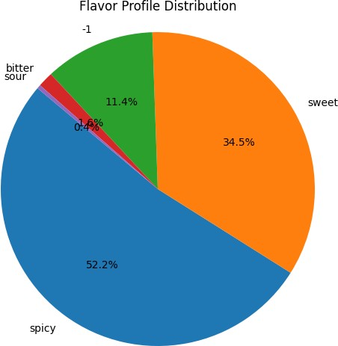

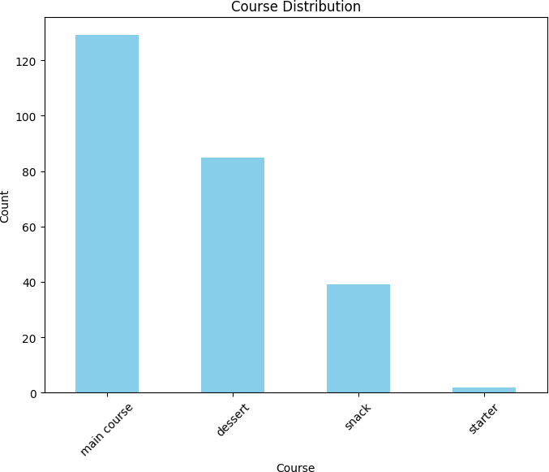

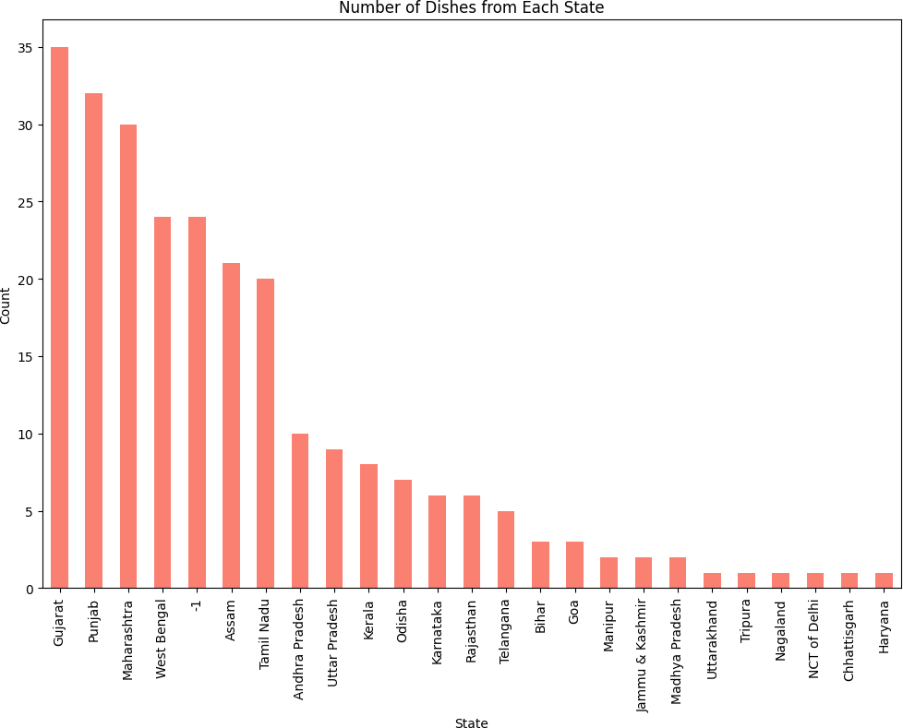

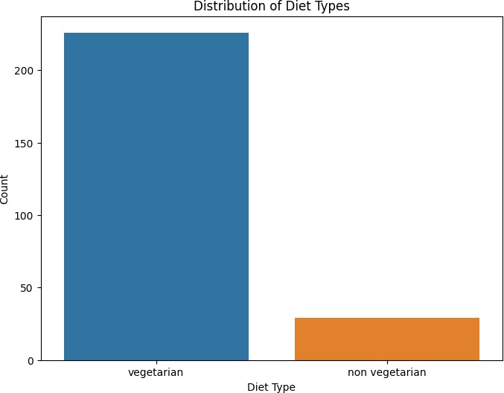

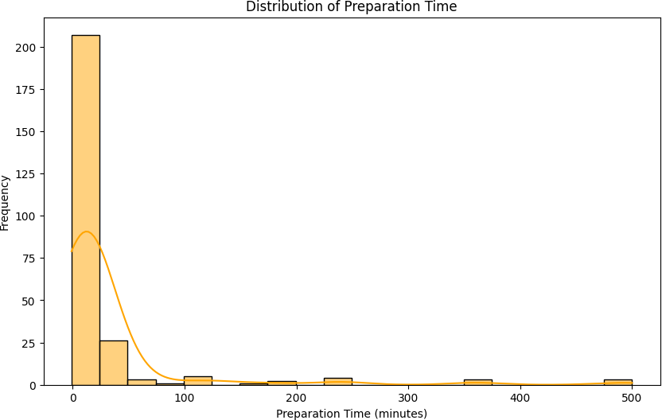

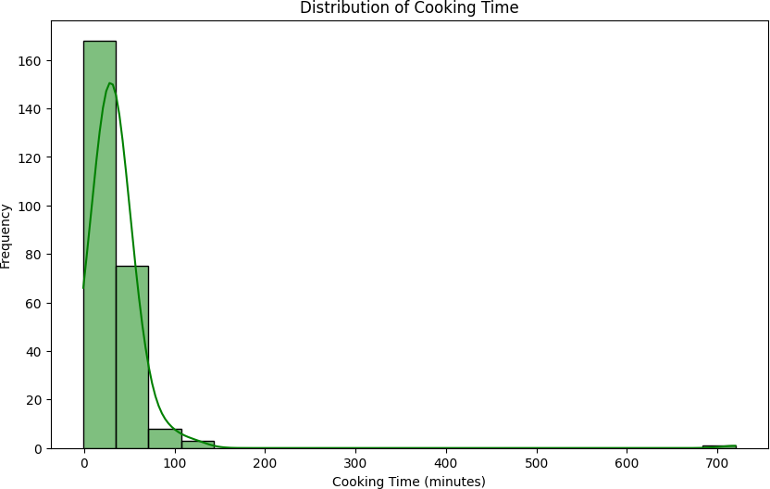

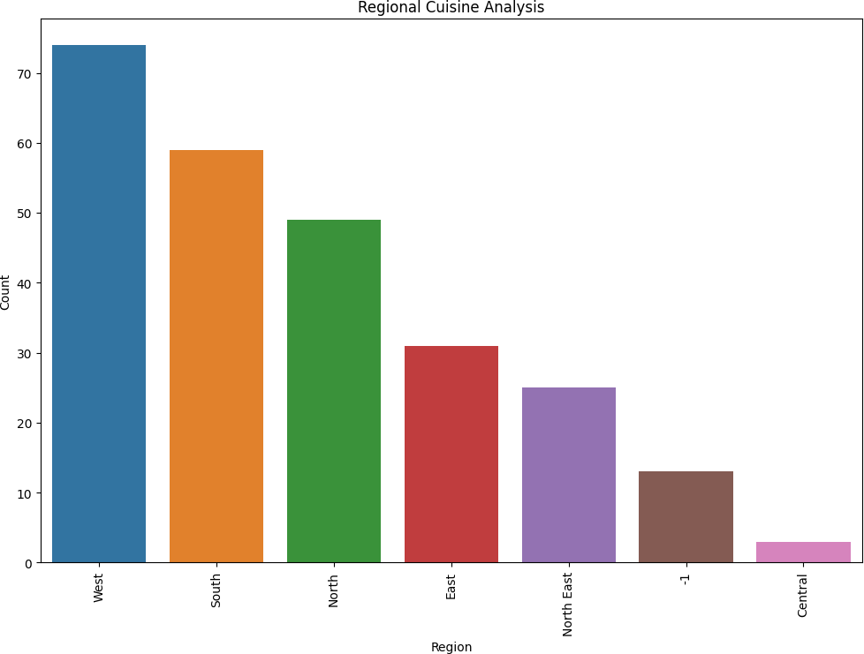

C:\Users\KIIT\AppData\Local\Temp\ipykernel_17060\139709188.py:66: FutureWarning: The default value of numeric_only in DataFrame.corr is deprecated. In a future version, it will default to False. Select only valid columns or specify the value of numeric_only to silence this warning.

sns.heatmap(data.corr(), annot=True, cmap='coolwarm')

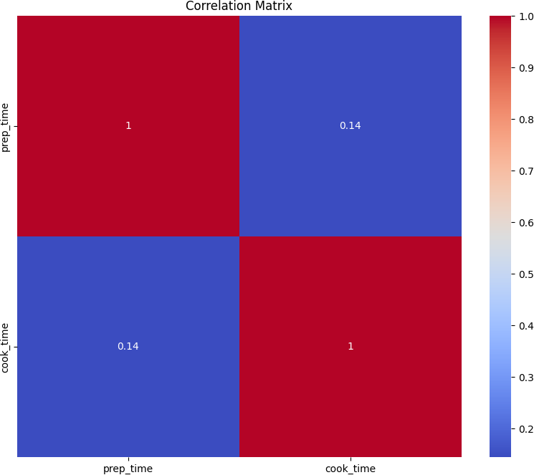

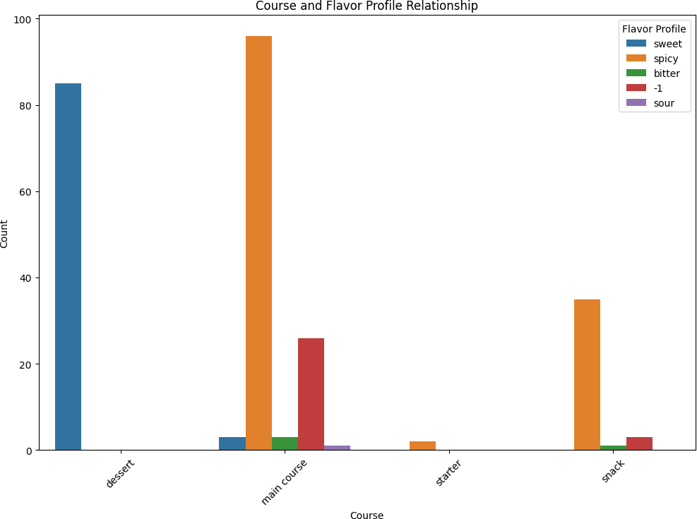

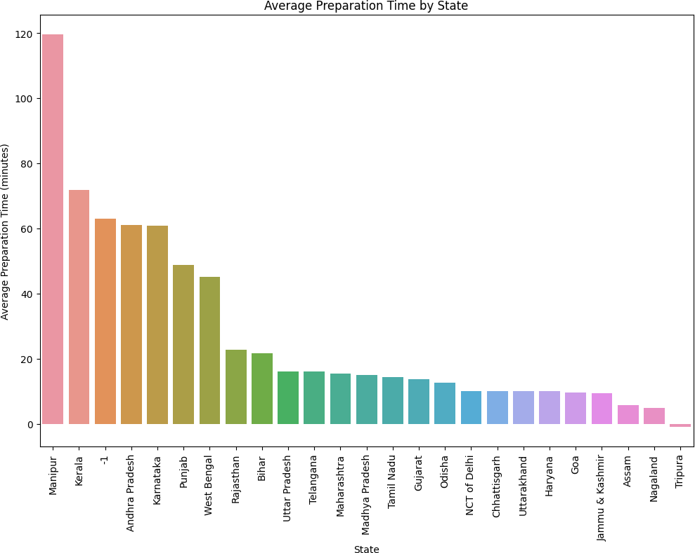

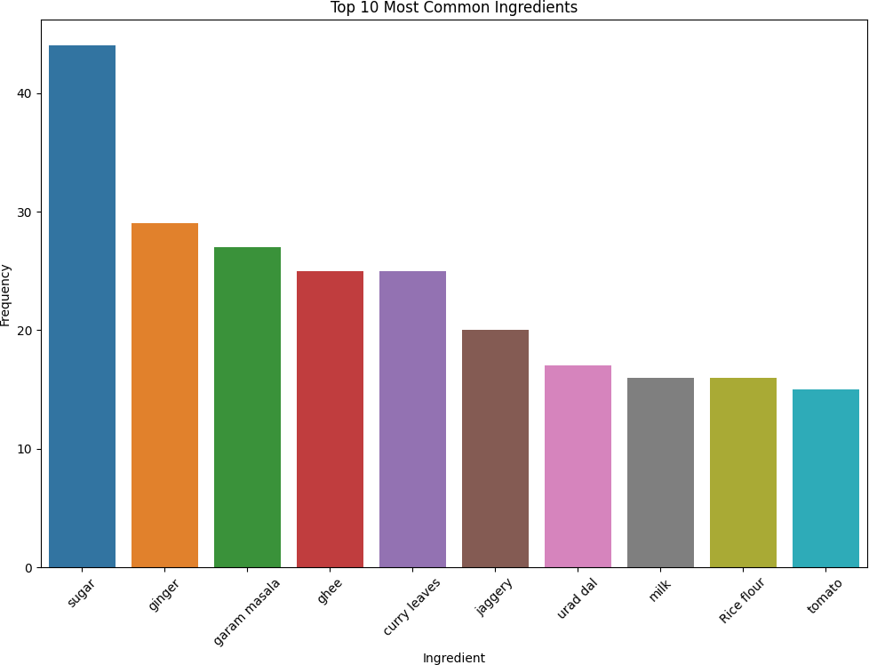

[ ]:

*# Filter vegetarian and non-vegetarian dishes* veg_data = data[data['diet'] == 'vegetarian'] non_veg_data = data[data['diet'] == 'non vegetarian']

*# Plotting preparation time for Veg and Non Veg dishes*

plt.figure(figsize=(10, 6))

sns.histplot(veg_data['prep_time'], bins=20, kde=**True**, color='green',␣

↪label='Vegetarian')

sns.histplot(non_veg_data['prep_time'], bins=20, kde=**True**, color='red',␣

↪label='Non Vegetarian')

plt.title('Comparison of Preparation Time for Veg and Non Veg Dishes') plt.xlabel('Preparation Time (minutes)')

plt.ylabel('Frequency') plt.legend()

plt.show()

*# Plotting cooking time for Veg and Non Veg dishes*

plt.figure(figsize=(10, 6))

sns.histplot(veg_data['cook_time'], bins=20, kde=**True**, color='blue',␣

↪label='Vegetarian')

sns.histplot(non_veg_data['cook_time'], bins=20, kde=**True**, color='orange',␣

↪label='Non Vegetarian')

plt.title('Comparison of Cooking Time for Veg and Non Veg Dishes') plt.xlabel('Cooking Time (minutes)')

plt.ylabel('Frequency') plt.legend()

plt.show()

*# Summary statistics for preparation time*

veg_prep_stats = veg_data['prep_time'].describe() non_veg_prep_stats = non_veg_data['prep_time'].describe()

*# Summary statistics for cooking time*

veg_cook_stats = veg_data['cook_time'].describe() non_veg_cook_stats = non_veg_data['cook_time'].describe()

*# Print the summary statistics* print("Preparation Time for Vegetarian Dishes:") print(veg_prep_stats)

print("**\n**Preparation Time for Non Vegetarian Dishes:") print(non_veg_prep_stats)

print("**\n**Cooking Time for Vegetarian Dishes:") print(veg_cook_stats)

print("**\n**Cooking Time for Non Vegetarian Dishes:") print(non_veg_cook_stats)

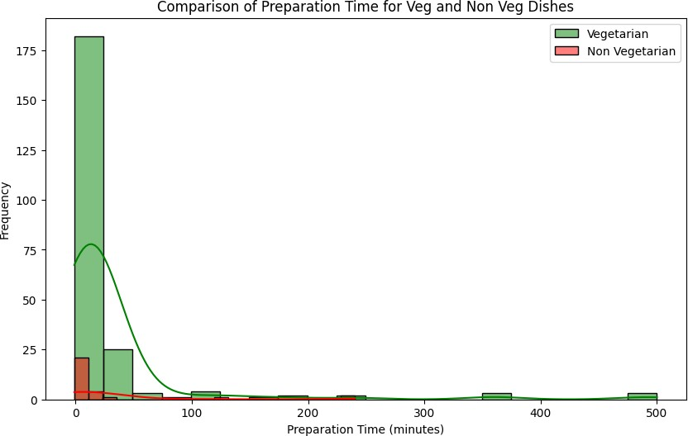

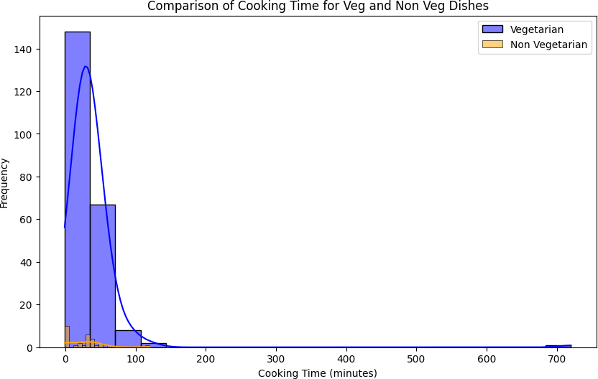

Preparation Time for Vegetarian Dishes: count 226.000000

|  |  |
| --- | --- |
| mean | 31.623894 |
| std | 73.794701 |
| min | -1.000000 |
| 25% | 10.000000 |
| 50% | 10.000000 |
| 75% | 20.000000 |
| max | 500.000000 |

Name: prep_time, dtype: float64

Preparation Time for Non Vegetarian Dishes:

|  |  |
| --- | --- |
| count | 29.000000 |
| mean | 27.068966 |
| std | 63.043597 |
| min | -1.000000 |
| 25% | -1.000000 |
| 50% | 10.000000 |
| 75% | 15.000000 |
| max | 240.000000 |

Name: prep_time, dtype: float64

|  |  |
| --- | --- |
| mean | 35.641593 |
| std | 50.296453 |
| min | -1.000000 |
| 25% | 20.000000 |
| 50% | 30.000000 |
| 75% | 40.000000 |
| max | 720.000000 |

Cooking Time for Vegetarian Dishes: count 226.000000

Name: cook_time, dtype: float64

Cooking Time for Non Vegetarian Dishes:

|  |  |
| --- | --- |
| count | 29.000000 |
| mean | 25.862069 |
| std | 26.768484 |
| min | -1.000000 |
| 25% | -1.000000 |
| 50% | 30.000000 |
| 75% | 40.000000 |
| max | 120.000000 |

Name: cook_time, dtype: float64

[ ]:

Most Popular Food: Balu shahi

Number of Dishes based on Flavor Profile:

spicy 133

sweet 88

-1 29

bitter 4

sour 1

Name: flavor_profile, dtype: int64

Number of Dishes based on Course:

main course 129

dessert 85

snack 39

starter 2

Name: course, dtype: int64

Number of Dishes from Each State:

Gujarat 35

Punjab 32

Maharashtra 30

West Bengal 24

-1 24

Assam 21

Tamil Nadu 20

Andhra Pradesh 10

Uttar Pradesh 9

Kerala 8

Odisha 7

Karnataka 6

Rajasthan 6

Telangana 5

Bihar 3

Goa 3

Manipur 2

Jammu & Kashmir 2

Madhya Pradesh 2

Uttarakhand 1

Tripura 1

Nagaland 1

NCT of Delhi 1

Chhattisgarh 1

Haryana 1

Name: state, dtype: int64

Number of Vegetarian Dishes: 226

Number of Non-Vegetarian Dishes: 29

|  |  |  |  |
| --- | --- | --- | --- |
| dishes | ingredients | diet | state |
| Balu shahi | Maida flour, yogurt, oil, sugar | vegetarian | West Bengal |
| Boondi | Gram flour, ghee, sugar | vegetarian | Rajasthan |
| Gajar ka halwa | Carrots, milk, sugar, ghee, cashews, raisins | vegetarian | Punjab |
| Ghevar | Flour, ghee, kewra, milk, clarified butter, sugar, almonds, pistachio, saffron, green cardamom | vegetarian | Rajasthan |
| Gulab jamun | Milk powder, plain flour, baking powder, ghee, milk, sugar, water, rose water | vegetarian | West Bengal |
| Imarti | Sugar syrup, lentil flour | vegetarian | West Bengal |
| Jalebi | Maida, corn flour, baking soda, vinegar, curd, water, turmeric, saffron, cardamom | vegetarian | Uttar Pradesh |
| Kaju katli | Cashews, ghee, cardamom, sugar | vegetarian | -1 |
| Kalakand | Milk, cottage cheese, sugar | vegetarian | West Bengal |
| Kheer | Milk, rice, sugar, dried fruits | vegetarian | -1 |
| Laddu | Gram flour, ghee, sugar | vegetarian | -1 |
| Lassi | Yogurt, milk, nuts, sugar | vegetarian | Punjab |
| Nankhatai | Refined flour, besan, ghee, powdered sugar, yoghurt, green cardamom | vegetarian | -1 |
| Petha | Firm white pumpkin, sugar, kitchen lime, alum powder | vegetarian | Uttar Pradesh |
| Phirni | Rice, sugar, nuts | vegetarian | Odisha |
| Rabri | Condensed milk, sugar, spices, nuts | vegetarian | Uttar Pradesh |
| Sheera | Semolina, ghee, nuts, milk | vegetarian | Maharashtra |
| Singori | Khoa, coconut, molu leaf | vegetarian | Uttarakhand |
| Sohan halwa | Corn flour, ghee, dry fruits | vegetarian | Uttar Pradesh |
| Sohan papdi | Gram flour, ghee, sugar, milk, cardamom | vegetarian | Maharashtra |
| Chhena jalebi | Chhena, sugar, ghee | vegetarian | Odisha |
| Chhena kheeri | Chhena, sugar, milk | vegetarian | Odisha |
| Chhena poda | Sugar, chenna cheese | vegetarian | Odisha |
| Cham cham | Flour, cream, sugar, saffron, lemon juice, coconut flakes | vegetarian | West Bengal |
| Kheer sagar | Chenna, condensed milk, sugar, saffron, cardamom | vegetarian | Odisha |
| Ledikeni | Chhena, sugar, ghee | vegetarian | West Bengal |
| Lyangcha | Flour, fried milk power, sugar syrup | vegetarian | Assam |
| Malapua | Yoghurt, refined flour, ghee, fennel seeds | vegetarian | Bihar |
| Mihidana | Besan flour, sugar, ghee | vegetarian | West Bengal |
| Misti doi | Milk, jaggery | vegetarian | West Bengal |
| Pantua | Chhena, sugar, ghee, flour | vegetarian | West Bengal |
| Pithe | Rice flour, wheat flour | vegetarian | Assam |
| Rasabali | Chenna, sweetened milk | vegetarian | Odisha |
| Ras malai | Chhena, reduced milk, pistachio | vegetarian | West Bengal |
| Rasgulla | Chhena, sugar, cardamom | vegetarian | West Bengal |
| Sandesh | Milk, sugar, saffron, cardamom | vegetarian | West Bengal |
| Adhirasam | Rice flour, jaggery, ghee, vegetable oil, elachi | vegetarian | West Bengal |
| Ariselu | Rice flour, jaggery, ghee | vegetarian | Andhra Pradesh |
| Bandar laddu | Besan, jaggery, cardamom powder, ghee, cashews and raisins, jaggery syrup, sugar | vegetarian | Andhra Pradesh |
| Chikki | Peanuts, jaggery | vegetarian | Maharashtra |
| Dharwad pedha | Milk, Sugar, Dharwadi buffalo milk | vegetarian | Karnataka |
| Double ka meetha | Loaf bread, milk | vegetarian | Telangana |
| Gavvalu | Rice flour, sugar, salt, ghee, semolina | vegetarian | Andhra Pradesh |
| Kakinada khaja | Wheat flour, sugar | vegetarian | Andhra Pradesh |
| Kuzhi paniyaram | Black lentils, rice | vegetarian | Kerala |
| Mysore pak | Besan flour, semolina, mung bean, jaggery, coconut, skimmed milk powder, sugar, ghee | vegetarian | Karnataka |
| Obbattu holige | Maida flour, turmeric, coconut, chickpeas, jaggery, ghee, cardamom | vegetarian | Karnataka |
| Palathalikalu | Rice flour, milk | vegetarian | Andhra Pradesh |
| Poornalu | Chana dal, jaggery | vegetarian | Andhra Pradesh |
| Pongal | Rice, jaggery, cashews, ghee | vegetarian | Tamil Nadu |
| Pootharekulu | Rice flour, powdered sugar, ghee | vegetarian | Andhra Pradesh |
| Qubani ka meetha | Apricots, sugar syrup | vegetarian | Telangana |
| Sheer korma | Vermicelli pudding, milk | vegetarian | Telangana |
| Unni Appam | Rice flour, banana, jaggery, coconut | vegetarian | Tamil Nadu |
| Kajjikaya | Rice flour, jaggery, coconut | vegetarian | Andhra Pradesh |
| Anarsa | Rice flour, jaggery, khus-khus seeds | vegetarian | Maharashtra |
| Basundi | Sugar, milk, nuts | vegetarian | Gujarat |
| Dhondas | Cucumber, rava | vegetarian | Maharashtra |
| Doodhpak | Milk, rice, sugar, dry fruits | vegetarian | Gujarat |
| Mahim halwa | Semolina, sugar | vegetarian | Maharashtra |
| Modak | Rice flour, coconut, jaggery | vegetarian | Maharashtra |
| Shankarpali | Sugar, ghee, maida flour, semolina | vegetarian | Maharashtra |
| Shrikhand | Curd, sugar, saffron, cardamom | vegetarian | Maharashtra |
| Sutar feni | Maida, sugar, ghee | vegetarian | Maharashtra |
| Maach Jhol | Fish, potol, tomato, chillies, ginger, garlic | non vegetarian | Assam |
| Pork Bharta | Boiled pork, onions, chillies, ginger and garlic | non vegetarian | Tripura |
| Chak Hao Kheer | Rice, milk, sugar, cardamom | vegetarian | Manipur |
| Galho | Rice, axone, salt, water, chillies, pork | non vegetarian | Nagaland |
| Aloo gobi | Cauliflower, potato, garam masala, turmeric, curry leaves | vegetarian | Punjab |
| Aloo tikki | Rice flour, potato, bread crumbs, garam masala, salt | vegetarian | Punjab |
| Aloo matar | Potato, peas, chillies, ginger, garam masala, garlic | vegetarian | Punjab |
| Aloo methi | Potato, fenugreek leaves, chillies, salt, oil | vegetarian | Punjab |
| Aloo shimla mirch | Potato, shimla mirch, garam masala, amchur powder, salt | vegetarian | Punjab |
| Bhatura | Chole, rava, yogurt, plain flour, baking soda | vegetarian | Punjab |
| Bhindi masala | Ladies finger, garam masala, kasuri methi, tomatoes, chili powder | vegetarian | Punjab |
| Biryani | Chicken thighs, basmati rice, star anise, sweet, green chillies | non vegetarian | Telangana |
| Butter chicken | Chicken, greek yogurt, cream, garam masala powder, cashew nuts, butter | non vegetarian | NCT of Delhi |
| Chana masala | Chickpeas, tomato paste, garam masala, ginger, red onion, avocado oil | vegetarian | Punjab |
| Chapati | Whole wheat flour, olive oil, hot water, all purpose flour | vegetarian | Maharashtra |
| Chicken razala | Chicken, dahi, sesame seeds, garam masala powder, cashew nuts, saffron | non vegetarian | West Bengal |
| Chicken Tikka masala | Naan bread, tomato sauce, skinless chicken breasts, heavy cream, garam masala | non vegetarian | Punjab |
| Chicken Tikka | Chicken, whole wheat bread, rice flour, garam masala powder, whole egg | non vegetarian | Punjab |
| Chole bhature | Chole, bhatura, garam masala, bay leaf, cinnamon stick | vegetarian | Punjab |
| Daal baati churma | Moong dal, masoor dal, chana dal, wheat flour, almond | vegetarian | Rajasthan |
| Daal puri | Moong dal, garam masala powder, garlic, green chilli, all purpose flour | vegetarian | West Bengal |
| Dal makhani | Red kidney beans, urad dal, cream, garam masala, chili powder | vegetarian | Punjab |
| Dal tadka | Pigeon peas, garam masala, ginger, red onion, kasuri methi | vegetarian | Punjab |
| Dum aloo | Baby potatoes, garam masala, cashew nuts, kasuri methi, tomatoes | vegetarian | Jammu & Kashmir |
| Poha | Beaten rice flakes, potato, curry leaves, green chilies, lemon juice | vegetarian | Maharashtra |
| Fara | Chana dal, whole wheat flour, arhar dal, white urad dal, garam masala powder | vegetarian | Chhattisgarh |
| Kachori | Moong dal, rava, garam masala, dough, fennel seeds | vegetarian | Uttar Pradesh |
| Kadai paneer | Cottage cheese, bell peppers, gravy, garam masala, cashew nuts | vegetarian | Punjab |
| Kadhi pakoda | Besan, garam masala powder, gram flour, ginger, curry leaves | vegetarian | Haryana |
| Karela bharta | Bitter gourd, fennel, garam masala powder, chili powder, amchur powder | vegetarian | Punjab |
| Khichdi | Moong dal, green peas, ginger, tomato, green chili | vegetarian | -1 |
| Kofta | Paneer, potato, cream, corn flour, garam masala | vegetarian | Uttar Pradesh |
| Kulfi falooda | Rose syrup, falooda sev, mixed nuts, saffron, sugar | vegetarian | -1 |
| Lauki ke kofte | Bottle gourd, garam masala powder, gram flour, ginger, chillies | vegetarian | Uttar Pradesh |
| Lauki ki subji | Bottle gourd, coconut oil, garam masala, ginger, green chillies | vegetarian | -1 |
| Litti chokha | Wheat flour, roasted gram flour, tomato, nigella seeds, chilli | vegetarian | Bihar |
| Makki di roti sarson da saag | Palak, makki atta, mustard green, garam masala, ginger | vegetarian | Punjab |
| Misi roti | Whole wheat flour, chickpea flour, green chilies | vegetarian | Punjab |
| Mushroom do pyaza | Mushroom, malai, garam masala, ginger, capsicum | vegetarian | Punjab |
| Mushroom matar | Canned coconut milk, frozen green peas, wild mushrooms, garam masala, tomatoes | vegetarian | Punjab |
| Naan | Whole wheat flour, honey, butter, garlic | vegetarian | Punjab |
| Navrattan korma | Green beans, potatoes, khus khus, low fat, garam masala powder | vegetarian | Uttar Pradesh |
| Palak paneer | Cottage cheese, palak, cream, garam masala, butter | vegetarian | Punjab |
| Paneer butter masala | Paneer, whipping cream, garam masala, cashew nuts, butter | vegetarian | Punjab |
| Paneer tikka masala | Paneer, greek yogurt, tandoori masala, cream, bell pepper | vegetarian | Punjab |
| Pani puri | Kala chana, mashed potato, boondi, sev, lemon | vegetarian | -1 |
| Panjeeri | Whole wheat flour, musk melon seeds, poppy seeds, edible gum, semolina | vegetarian | Uttar Pradesh |
| Papad | Urad dal, sev, lemon juice, chopped tomatoes | vegetarian | -1 |
| Paratha | Wheat flour, butter, potato, coriander | vegetarian | Punjab |
| Pattor | Arbi ke patte, sesame seeds, gur, bengal gram flour, imli | vegetarian | Rajasthan |
| Pindi chana | Fennel, tea bags, tomato, kasuri methi, cinnamon | vegetarian | Punjab |
| Rajma chaval | Red kidney beans, garam masala powder, ginger, tomato, mustard oil | vegetarian | -1 |
| Rongi | Garam masala powder, tomato, kasuri methi, cinnamon, mustard oil | vegetarian | Punjab |
| Samosa | Potatoes, green peas, garam masala, ginger, dough | vegetarian | -1 |
| Sattu ki roti | Sattu, atta, dough, filling, mustard oil | vegetarian | Bihar |
| Shahi paneer | Cottage cheese, malai, garam masala, ginger, tomato | vegetarian | Punjab |
| Shahi tukra | Rose water, milk, white bread slices, saffron, almonds | vegetarian | Telangana |
| Vegetable jalfrezi | Baby corn, french beans, garam masala, ginger, carrot | vegetarian | Punjab |
| Tandoori Chicken | Greek yogurt, garam masala, kasuri methi, marinade, mustard oil | non vegetarian | Punjab |
| Tandoori Fish Tikka | Chickpea flour, biryani masala powder, yogurt, fish fillets, green bell pepper | non vegetarian | Punjab |
| Attu | Whole wheat flour, arhar dal, ginger, kala jeera, green chilli | vegetarian | Andhra Pradesh |
| Avial | Raw banana, elephant foot yam, long beans, tindora, urad dal | vegetarian | Kerala |
| Bisi bele bath | Split pigeon peas, chana dal, urad dal, green peas, french beans | vegetarian | Karnataka |
| Currivepillai sadam | Chana dal, urad dal, fresh coconut, sesame seeds, curry leaves | vegetarian | Tamil Nadu |
| Dosa | Chana dal, urad dal, whole urad dal, blend rice, rock salt | vegetarian | -1 |
| Idiappam | Rice flour, hot water, grated coconut | vegetarian | Tamil Nadu |
| Idli | Split urad dal, urad dal, idli rice, thick poha, rock salt | vegetarian | -1 |
| Kanji | Carrot, yellow mustard, red chilli, black salt | vegetarian | Kerala |
| Kaara kozhambu | Sesame oil, drumstick, tamarind paste, sambar powder, tomato | vegetarian | Tamil Nadu |
| Keerai kootu | Moong dal, chana dal, spinach, urad dal, coconut oil | vegetarian | Tamil Nadu |
| Keerai masiyal | Urad dal, curry leaves, sugar, mustard seeds, spinach | vegetarian | Tamil Nadu |
| Keerai sadam | Greens, tomato, mustard seeds, fenugreek seeds | vegetarian | Tamil Nadu |
| Keerai poriyal | Amaranth leaves, split urad dal, mustard seeds, grated coconut, red chili | vegetarian | Tamil Nadu |
| Beef Fry | Beef, coconut, garam masala, curry leaves, green chilies, chili powder | non vegetarian | Kerala |
| Kootu | Chana dal, urad dal, potato, beans, peas | vegetarian | Tamil Nadu |
| Kos kootu | Moong dal, chana dal, cabbage, tamarind, curry leaves | vegetarian | Tamil Nadu |
| Koshambri | Moong dal, cucumber, curry leaves, green chili, lemon juice | vegetarian | Karnataka |
| Kothamali sadam | Chana dal, urad dal, gooseberry, raw rice, curry leaves | vegetarian | Tamil Nadu |
| Kuzhakkattai | Sesame oil, raw rice, jaggery, grated coconut | vegetarian | Tamil Nadu |
| Kuzhambu | Pearl onions, urad dal, drumsticks, tomato, curry leaves | vegetarian | Tamil Nadu |
| Masala Dosa | Chana dal, urad dal, potatoes, idli rice, thick poha | vegetarian | -1 |
| Pachadi | Coconut oil, cucumber, curd, curry leaves, mustard seeds | vegetarian | -1 |
| Paniyaram | Yogurt, ginger, curry leaves, baking soda, green chilli | vegetarian | Tamil Nadu |
| Papadum | Lentils, black pepper, vegetable oil | vegetarian | Kerala |
| Paravannam | Raw rice, jaggery, milk | vegetarian | Kerala |
| Payasam | Rice, cashew nuts, milk, raisins, sugar | vegetarian | -1 |
| Paruppu sadam | Arhar dal, sambar powder, tomato, curry leaves, fennel seeds | vegetarian | Tamil Nadu |
| Pesarattu | Green moong beans, rice flour | vegetarian | Andhra Pradesh |
| Poriyal | Chana dal, urad dal, beans, coconut, mustard | vegetarian | Tamil Nadu |
| Puli sadam | Urad dal, lemon, tamarind, cooked rice, curry leaves | vegetarian | Tamil Nadu |
| Rasam | Tomato, curry leaves, garlic, mustard seeds, hot water | vegetarian | -1 |
| Puttu | Brown rice flour, sugar, grated coconut | vegetarian | Kerala |
| Sambar | Pigeon peas, eggplant, drumsticks, sambar powder, tamarind | vegetarian | -1 |
| Sandige | Thin rice flakes, black sesame seeds, curry leaves | vegetarian | Karnataka |
| Sevai | Sevai, parboiled rice, steamer | vegetarian | -1 |
| Thayir sadam | Urad dal, curd, sesame oil, ginger, curry leaves, mustard seeds | vegetarian | Tamil Nadu |
| Theeyal | Coconut, whole red beans, masala, sesame oil, tamarind | vegetarian | Kerala |
| Uttapam | Chana dal, urad dal, thick poha, tomato, butter | vegetarian | -1 |
| Vada | Urad dal, ginger, curry leaves, green chilies, black pepper | vegetarian | -1 |
| Chicken Varuval | Meat curry powder, chicken chunks, ginger, tomato, cinnamon | non vegetarian | Tamil Nadu |
| Upma | Chana dal, urad dal, ginger, curry leaves, sugar | vegetarian | -1 |
| Amti | Kala masala, arhar dal, curry leaves, mustard seeds, hot water | vegetarian | Maharashtra |
| Zunka | Gram flour, mustard, garlic, turmeric, red chilli | vegetarian | Maharashtra |
| Kolim Jawla | Baingan, fish, coconut oil, fresh coconut, ginger | non vegetarian | Maharashtra |
| Saath | Urad dal, potatoes, wheat flour, sooji | vegetarian | Gujarat |
| Bajri no rotlo | Wheat flour, pearl millet flour, hot water | vegetarian | Gujarat |
| Coconut vadi | Condensed milk, mawa, desiccated coconut, almonds, cashews | vegetarian | Maharashtra |
| Bhakri | Jowar flour, sesame seeds | vegetarian | Maharashtra |
| Bombil fry | Bombay duck, malvani masala, rice flour, bombay rava, green chilies | non vegetarian | Maharashtra |
| Chakali | Rice flour, sesame, plain flour, turmeric, red chilli | vegetarian | Maharashtra |
| Chevdo | Citric acid, fry, raisins, sugar, chana daal | vegetarian | Gujarat |
| Chorafali | Urad dal, bengal gram flour, dried mango, baking soda, black salt | vegetarian | Gujarat |
| Copra paak | Condensed milk, nestle cream, coconut ice, red food coloring, desiccated coconut | vegetarian | Gujarat |
| Daal Dhokli | Whole wheat flour, dal, kokum, gur, bengal gram flour | vegetarian | Gujarat |
| Kutchi dabeli | Pav, aloo, peanut, pomegranate, star anise | vegetarian | Gujarat |
| Dahi vada | Urad dal, bhuna chana, garam masala, dates, tamarind | vegetarian | Maharashtra |
| Dalithoy | Arhar dal, coconut oil, curry leaves, mustard seeds, red chilli | vegetarian | Maharashtra |
| Dhokla | Rava, coconut, gram flour, mustard, sesame | vegetarian | Gujarat |
| Dudhi halwa | Bottle gourd, green, raisins, sugar, clarified butter | vegetarian | Gujarat |
| Gatta curry | Yogurt, besan, sauce, garam masala powder, gram flour | vegetarian | Rajasthan |
| Gud papdi | Wheat flour, jaggery, clarified butter, sliced almonds | vegetarian | Gujarat |
| Ghooghra | Dry fruits, semolina, all purpose flour | vegetarian | Gujarat |
| Handwo | Bottle gourd, chana dal, cabbage, urad dal, toor dal | vegetarian | Gujarat |
| Halvasan | Whole wheat rava, chia seed, lemon, edible gum, milk | vegetarian | Gujarat |
| Jeera Aloo | Green chilies, lemon juice, chili powder, boiled potatoes | vegetarian | Gujarat |
| Kansar | Wheat flour, cashews, rapeseed oil | vegetarian | Gujarat |
| Keri no ras | Mango, sugar | vegetarian | Gujarat |
| Khakhra | Whole wheat flour, low fat, bengal gram flour | vegetarian | Gujarat |
| Khandvi | Green chili paste, white sesame seeds, gram flour, curry leaves, green chili | vegetarian | Gujarat |
| Kombdi vade | Rice flour, urad dal, wheat flour, gram flour, turmeric | vegetarian | Maharashtra |
| Laapsi | Cinnamon, jaggery, clarified butter, dry roasted | vegetarian | Madhya Pradesh |
| Koshimbir | Cucumber, carrot, tomatoes, cilantro | vegetarian | Maharashtra |
| Methi na Gota | Rava, gram flour, lemon juice, turmeric, fenugreek leaves | vegetarian | Gujarat |
| Mohanthal | Rose water, pistachio, badam, bengal gram flour, saffron | vegetarian | Gujarat |
| Muthiya | Bottle gourd, whole wheat flour, rava, sesame seeds, bengal gram flour | vegetarian | Gujarat |
| Patra | Arbi ke patte, sesame seeds, gur, bengal gram flour, imli | vegetarian | Gujarat |
| Pav Bhaji | Pav bhaji masala, gobi, potatoes, green peas, dinner rolls | vegetarian | Maharashtra |
| Puri Bhaji | Aloo, urad dal, mustard, ginger, curry leaves | vegetarian | Maharashtra |
| Sabudana Khichadi | Raw peanuts, sabudana, lemon, avocado oil, curry leaves, green chili | vegetarian | Maharashtra |
| Sev khamani | Khaman, pomegranate, sev, powdered sugar, garlic | vegetarian | Gujarat |
| Sev tameta | Sev, ginger, tomato, sugar | vegetarian | Gujarat |
| Namakpara | Wheat flour, baking soda, all purpose flour, black pepper, sunflower oil | vegetarian | Gujarat |
| Sukhdi | Whole wheat flour, gur, clarified butter | vegetarian | Maharashtra |
| Surnoli | Rice flakes, yogurt, raw rice, jaggery, grated coconut | vegetarian | Maharashtra |
| Thalipeeth | Whole wheat flour, rice flour, pearl millet flour, sorghum flour, sesame seeds | vegetarian | Maharashtra |
| Undhiyu | Sweet potato, surti papdi, baby potatoes, valor papdi, green peas | vegetarian | Gujarat |
| Veg Kolhapuri | Gobi, potato, beans, khus khus, coconut | vegetarian | Maharashtra |
| Vindaloo | Chicken, coconut oil, wine vinegar, ginger, green, cinnamon | non vegetarian | Goa |
| Lilva Kachori | Green garlic chutney, fresh green peas, ginger, lemon juice, plain flour | vegetarian | Gujarat |
| Mag Dhokli | Moong beans, jaggery, red chillies, oil, salt | vegetarian | Gujarat |
| Khichu | Rice flour, sesame seeds, baking soda, peanut oil | vegetarian | Gujarat |
| Thepla | Chickpea flour, methi leaves, jowar flour, wheat flour | vegetarian | Gujarat |
| Farsi Puri | Semolina, clarified butter, oil, white flour, black pepper | vegetarian | Gujarat |
| Khaman | Yogurt, fresh coconut, sesame seeds, semolina, gram flour | vegetarian | Gujarat |
| Turiya Patra Vatana sabji | Ridge gourd, baking soda, sugar, grated coconut, peas | vegetarian | Gujarat |
| Churma Ladoo | Whole wheat flour, khus khus, sesame seeds, dry coconut, gur | vegetarian | Rajasthan |
| Cheera Doi | Rice, mango, curd | vegetarian | West Bengal |
| Gheela Pitha | Sticky rice, rice flour, jaggery, orange rind | vegetarian | Assam |
| Khar | Raw papaya, panch phoran masala, nigella seeds, mustard oil, fennel seeds | vegetarian | Assam |
| Kumol Sawul | Rice, eggs, carrot, beetroot | non vegetarian | Assam |
| Luchi | Maida, vegetable oil | vegetarian | West Bengal |
| Alu Pitika | Potatoes, mustard oil, fish, green chillies | non vegetarian | Assam |
| Masor tenga | Ridge gourd, fish, lemon, tomatoes, mustard oil | non vegetarian | Assam |
| Bengena Pitika | Brinjal, onions, salt, sesame seeds, coriander | vegetarian | Assam |
| Bilahi Maas | Potatoes, garam masala, tomatoes, mustard oil, bay leaf | non vegetarian | Assam |
| Black rice | Forbidden black rice, chicken, olive oil, slivered almonds, garlic powder | non vegetarian | Manipur |
| Bora Sawul | Biryani masala, mixed vegetables, yellow moong daal, whole red, mustard seeds | vegetarian | Assam |
| Brown Rice | Brown rice, soy sauce, olive oil | vegetarian | -1 |
| Chingri malai curry | Coconut milk, lobster, fresh green chilli, ginger, red onion | non vegetarian | West Bengal |
| Goja | Baking soda, clarified butter, oil, all purpose flour | vegetarian | West Bengal |
| Hando Guri | Jaggery, raisins | vegetarian | Assam |
| Haq Maas | Lamb, garam masala powder, curd, turmeric, bay leaf | non vegetarian | Assam |
| Chingri Bhape | Coconut, prawns, curd, mustard seed, green chili | non vegetarian | West Bengal |
| Kabiraji | Fish fillet, besan, lemon, mint, ginger | non vegetarian | West Bengal |
| Khorisa | Fermented bamboo shoot, potato, ginger, green, mustard oil | vegetarian | Assam |
| Koldil Chicken | Banana flower, chicken, green chili, mustard oil, lemon juice | non vegetarian | Assam |
| Konir Dom | Aloo, tomatoes, mustard oil, bay leaf, cinnamon stick | non vegetarian | Assam |
| Koldil Duck | Rice flour, mutton, banana, gram flour, olive oil, baking powder | non vegetarian | Assam |
| Masor Koni | Fish roe, pumpkin flowers, mustard oil, turmeric, tomato | non vegetarian | Assam |
| Mishti Chholar Dal | Chana dal, fresh coconut, ginger, cinnamon, raisins | vegetarian | West Bengal |
| Pakhala | Curd, cooked rice, curry leaves, dry chilli | vegetarian | Odisha |
| Pani Pitha | Tea leaves, white sesame seeds, dry coconut, soaked rice | vegetarian | Assam |
| Payokh | Basmati rice, rose water, sugar, clarified butter, cardamom pods | vegetarian | Assam |
| Prawn malai curry | Coconut milk, prawns, garlic, turmeric, sugar | non vegetarian | West Bengal |
| Red Rice | Red pepper, red onion, butter, watercress, olive oil | vegetarian | -1 |
| Shukto | Green beans, bitter gourd, ridge gourd, banana, brinjal | vegetarian | West Bengal |
| Til Pitha | Glutinous rice, black sesame seeds, gur | vegetarian | Assam |
| Bebinca | Coconut milk, egg yolks, clarified butter, all purpose flour | vegetarian | Goa |
| Shufta | Cottage cheese, dry dates, dried rose petals, pistachio, badam | vegetarian | Jammu & Kashmir |
| Mawa Bati | Milk powder, dry fruits, arrowroot powder, all purpose flour | vegetarian | Madhya Pradesh |
| Pinaca | Brown rice, fennel seeds, grated coconut, black pepper, ginger powder | vegetarian | Goa |